**NAAN MUDHALVAN**

**CALCULATING FAMILY EXPENSES USING SERVICENOW**

**FAMILY EXPENSES TABLE:**

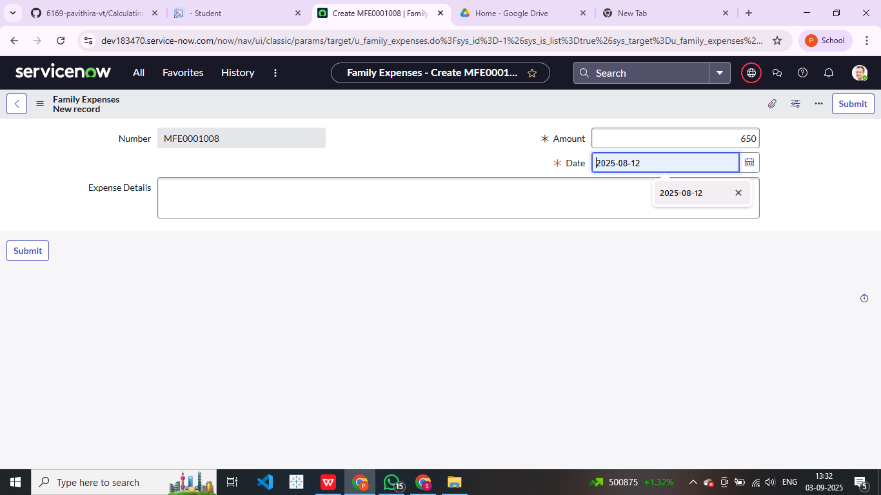

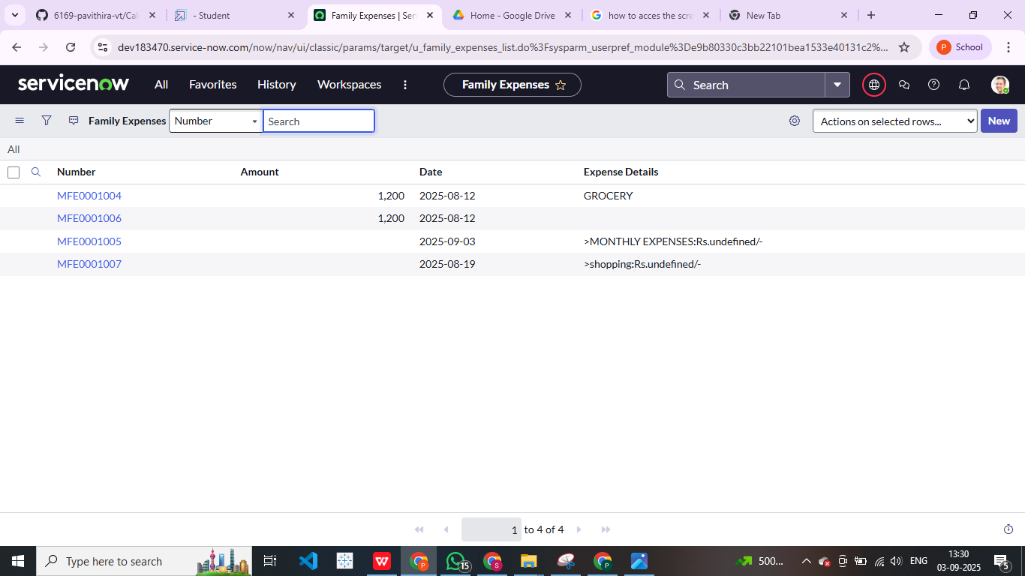

**DAILY EXPENSES:**

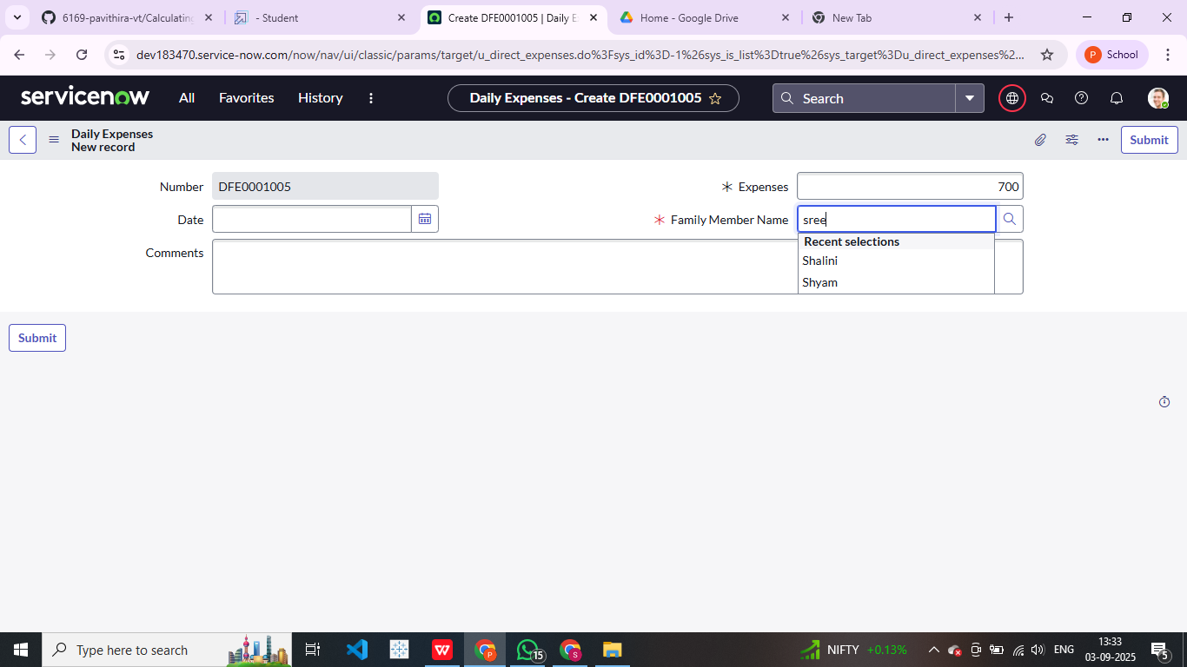

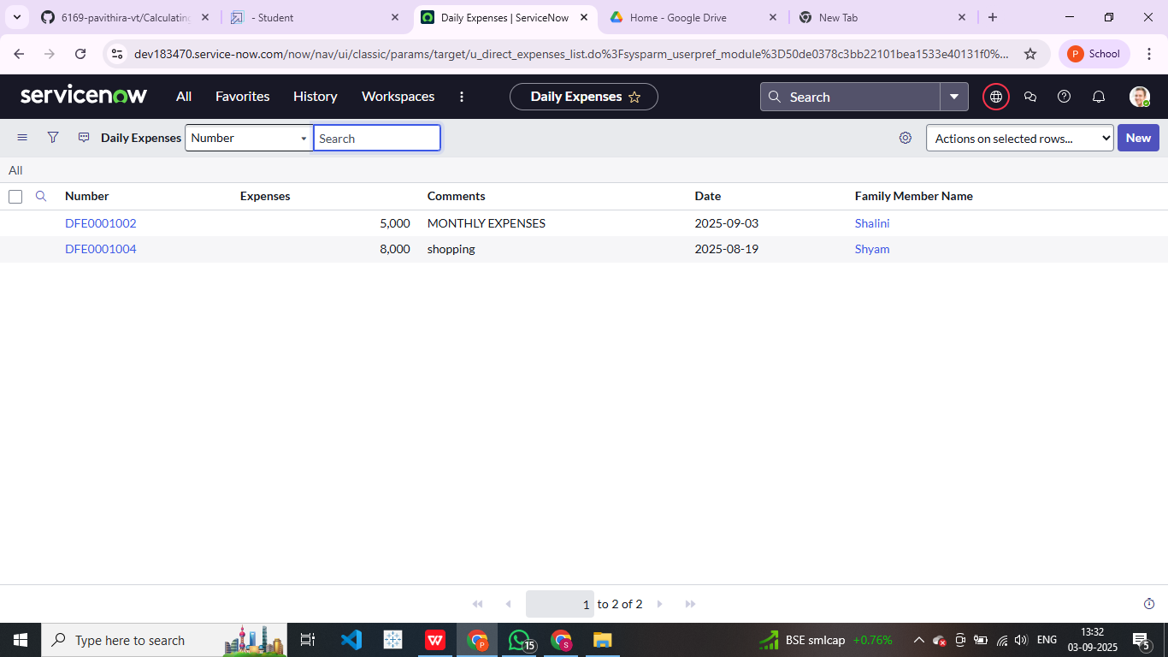

**TABLES CREATED :**

